Find out what are the top 5 categories with maximum number of videos uploaded.

//Driver class

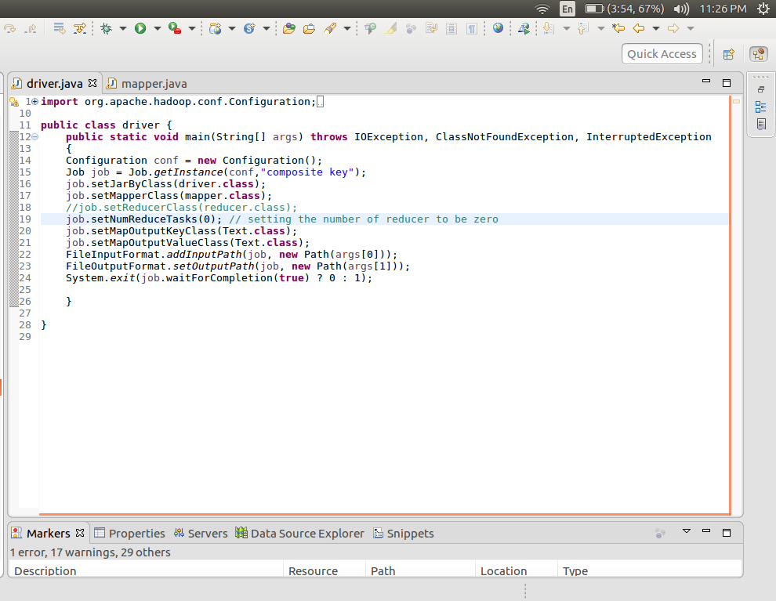

//Mapper Class

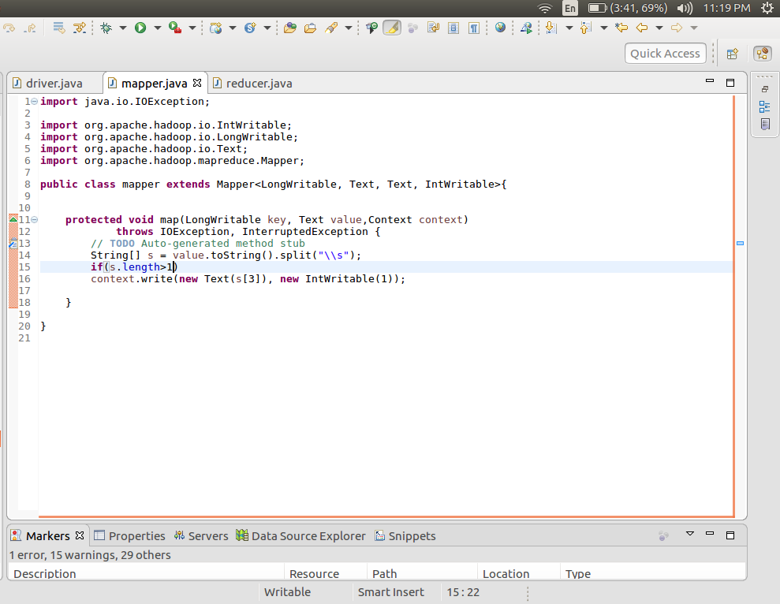

Splitting is done according one or more spaces

Here passing the Category as the key and intWritable 1 as the value. Hence for each occasion of the every category the value sent will be 1.

//reducer

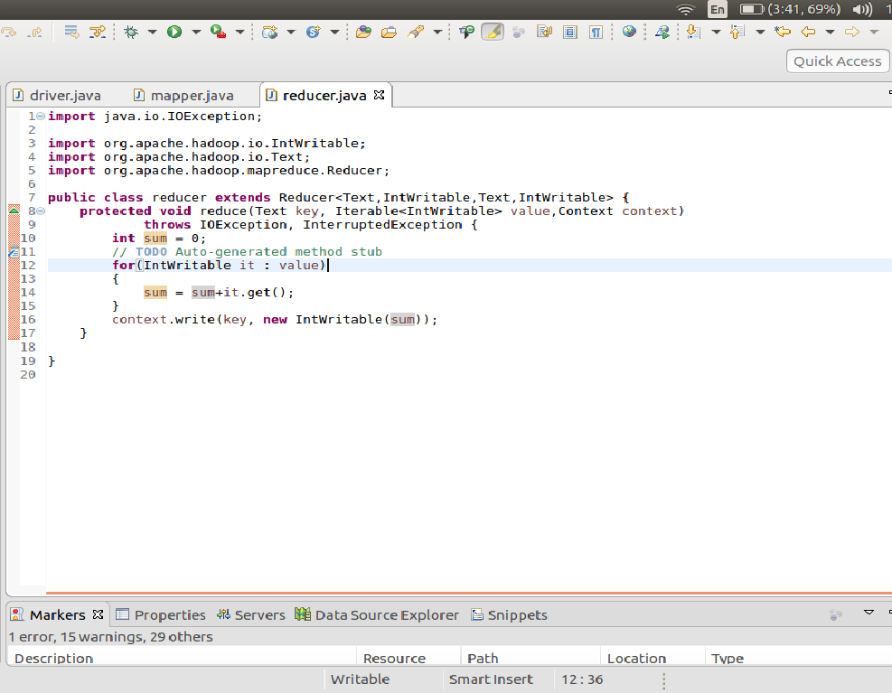

Here I am summing up the values that for each category and getting the number of videos in each category.

//output

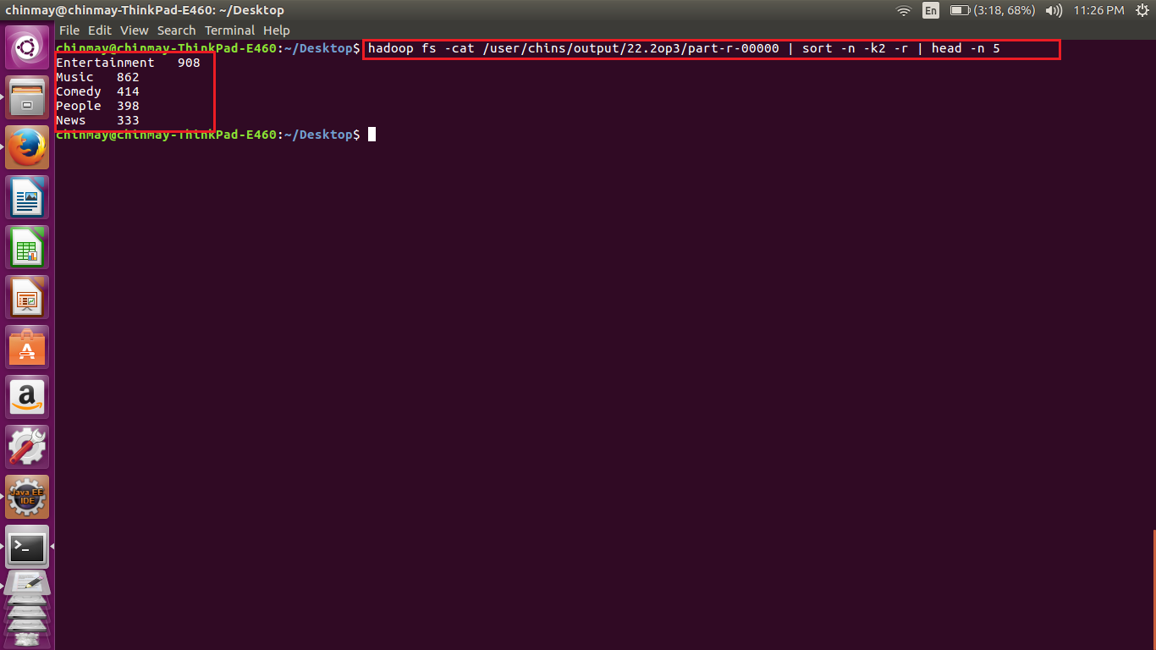

Here for displaying the top 5 values. I am using the phrase sort –n –k2 –r which sorts the file in the reverse order of the second column. Head –n 5 displays the top 5 values. By this get the top 5 categories.

Find the top 10 rated videos in youtube.

//driver

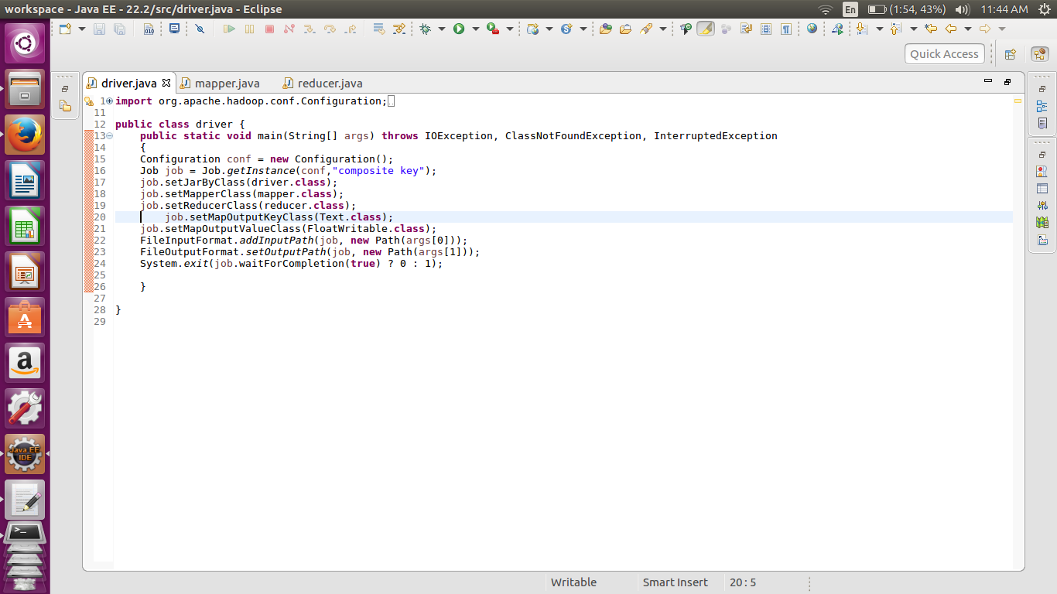

//mapper

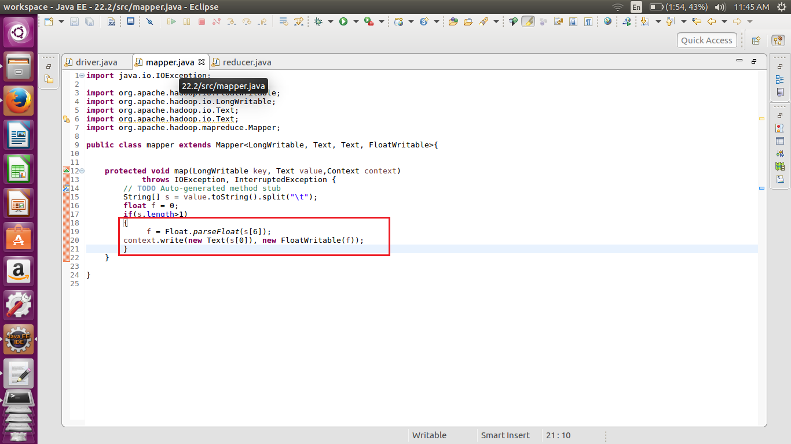

We are passing the rating given by each user in float wriatble.

//reducer

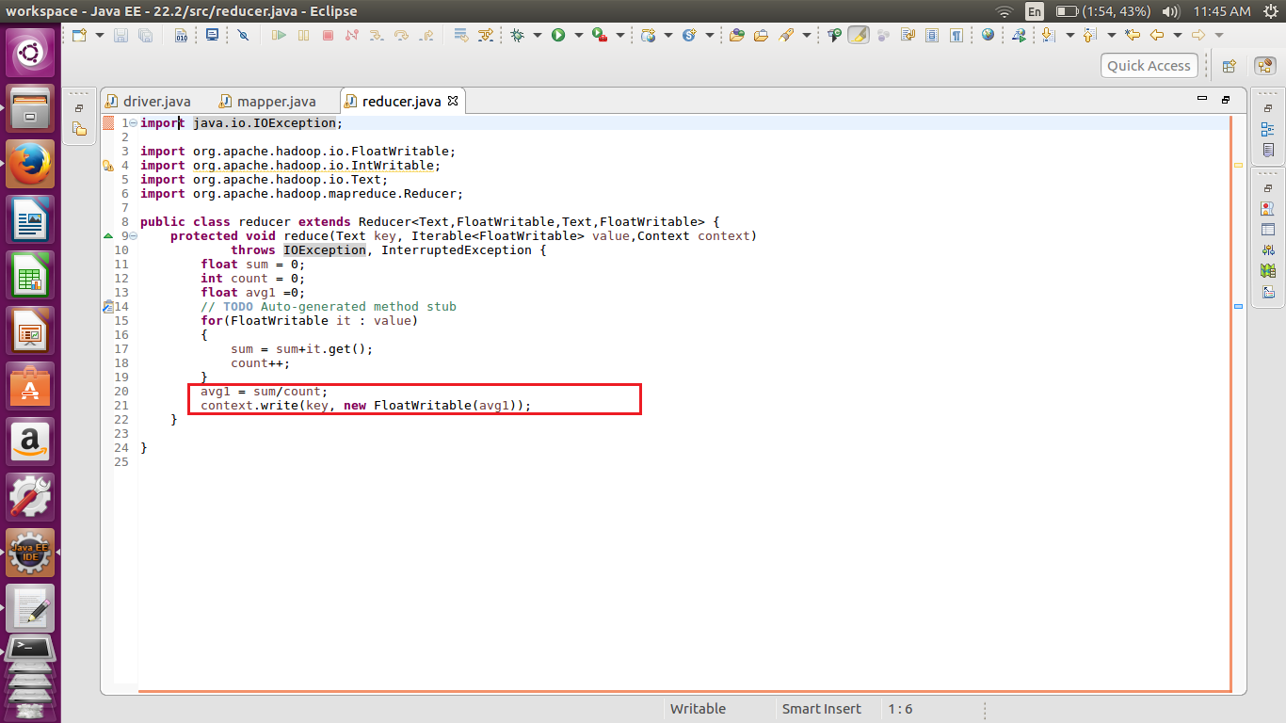

For finding out the top rated video we have to find the avg rating of each video. Hence in the reducer we are calculating the avg value and passing the float value as the value to the each key.

//implementation

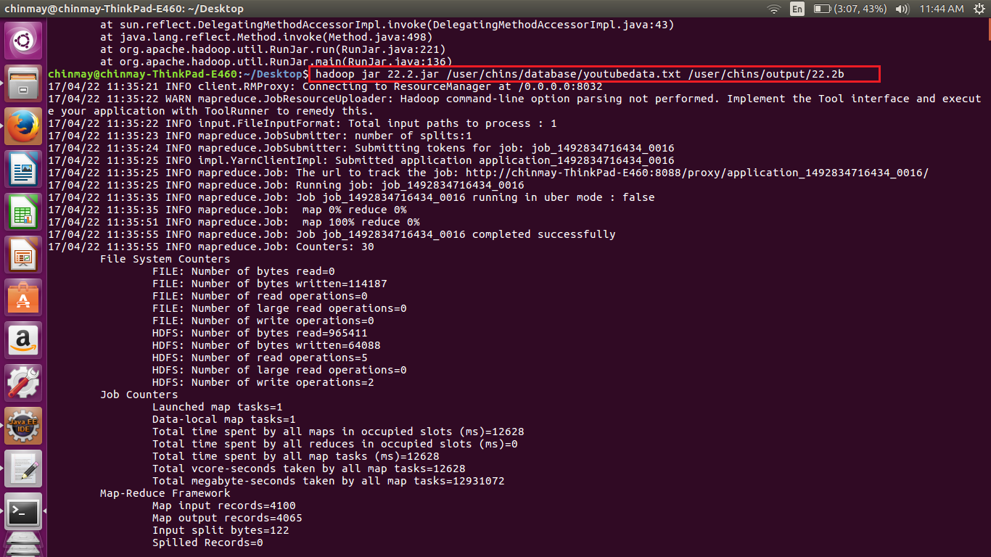

//output

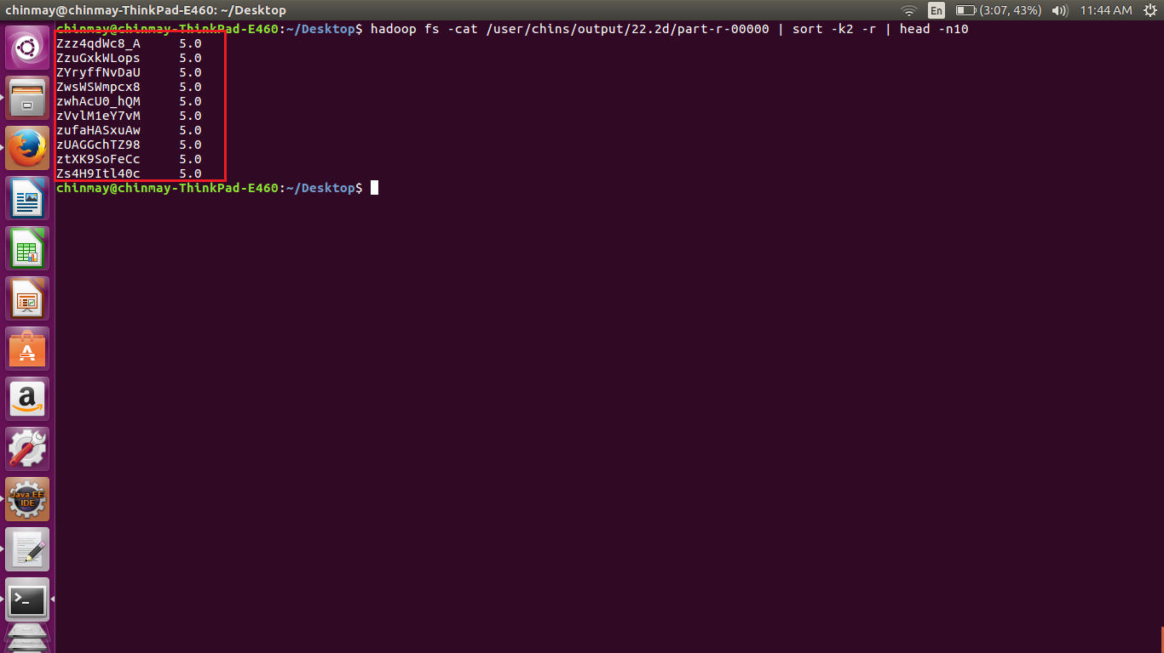

For getting the top 10 values we are using sort –k2 -r .

K2 will select second column and –r will arrange in the reverse order. The head command will give the top 10 values.